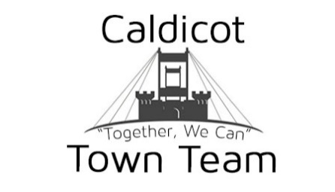

2020/2021 Directors & Financial Report

Covid dominated all aspects of life during the 2020/2021 financial year for Caldicot Town Team, Our focus shifted dramatically away from events and markets, to providing support and a voice for our businesses, town centre and for local residents.

Business Resilience Forum

A new multi-agency business resilience forum was created by Monmouthshire County Council in response to the unprecedented difficulties facing the business sector. The Forum is made up of Chamber of Commerce, and key stakeholders within the business sector including Caldicot Town Team, Welsh Government representatives, Business Rates teams, Licencing and public protection and other officers within Monmouthshire County Council. Meetings have been held regularly, virtually and together we have helped secure vital business grant funds for businesses across the Monmouthshire county, with our focus being on Caldicot. Meetings still continue to take place regularly and look into all areas, such as reopening town centres safely, bringing diversity to our town, ensuring businesses are able to access and receive funds and look at supporting new businesses who wish to open in the area.

Directors of Caldicot Town Team

The Directors of Caldicot Town Team stayed the same during the financial period. Those Directors were Aaron Reeks, Cathy Edwards and Julie White

Events and Markets

Neither Events, nor Markets were able to be carried out for most of the year, with just 2 markets taking place in 2020. Our Shop Local event in September and our Christmas Market on the 4th December

Community Support

As events and markets weren’t able to continue as normal, we turned our attention to community support. We have provided over 2,500 school packs for local children in the area, to help provide them with full packs including materials and stationary so work can continue at home. These were provided for free, with donation pots and donations received to help raise funds.

We provided all bungalows with a cream tea package as a project to reach out to our older members of the community, this was a heart-warming project which we know from speaking to residents that they were very grateful and thought the project was thoughtful and reminded those that they are not alone, even if they are isolated due to constraints from Covid.

Caldicot Town Team was very thrilled to be able to take part and hold a remembrance service at Caldicot Cross to remember all those who had lost loved ones in the last year. Sky News filmed live from the Cross while the service took place. The service was joined by members who had lost loved ones, and from all walks and ages, which added to the experience.

Moving Forward

2021 is still going to be dominated by Covid, however we are committed to putting our efforts into supporting businesses, into provide great, free to attend events in Caldicot for locals and families and helping to reopen and work on projects to provide a more diverse town centre.

Our 2020/2021 Action Plan was for the most part shelved, due to the Covid restrictions and we will be picking this up over the 2021/2022 financial year.

Finances

Like all matters over the last 12 months, Covid has also dominated our financials. Running costs increased, due to purchasing and implementing Covid safe practices, including Covid screens for our markets, at over £1,150 for these alone.

Income was significantly down in terms of event and market income, but we have been lucky enough to receive £9,000 in Covid Grants throughout the year. This was separated and segmented against community projects, such as the Cream Teas £440, our school packs, £2,000 and Running Costs £5,000.

We were able to bring in some income to offset the negative cost of hosting Hoggin The Bridge in previous years of £745.

Caldicot Goes Pop! Reopened in 2021 along with our office, and this has provided some diversity with retail in Caldicot, with local businesses hiring pitches and space within the premises. This has cost £949 for the financial year, however we have been lucky enough to receive funding since then to help offset this cost (will be reflected in 2021/2022 Accounts due to payment dates)

Markets have bought in a very small profit on its own, however due to the short notice cancellation of the Christmas events due to lockdown, this has been offset in terms of refunds for pitches and lost deposits against bookings.

Directors are happy to sign off on the 2020/2021 accounts and seek approval from Caldicot Town Team Members.

Completed by: Aaron Reeks (Voluntary Director)

