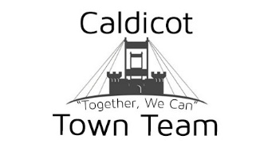

Tel: 07716 557289(Aaron)
Twitter: @CaldicotTT Facebook: Caldicot Town Team
Email: caldicottownteam@outlook.com Website: www.caldicottownteam.co.uk
To whom it may concern,

Caldicot Town Team are pleased to be hosting our 4th annual Family Fun Day on Friday August the 3rd in the Town Centre to mark the end of the school term and to celebrate the start of the summer holidays. We are looking for sponsors to contribute towards one or part of our planned attractions and activities in return for company advertising at the event, this year’s event will be bigger and better and will include Dinosaurs, Donkeys, bouncy castles, circus workshop, face painting, DJ, and much more. We are also planning to arrange a display area where some local groups and organisations can perform.
With the event run entirely by volunteers we rely on donations to be able to keep promoting our town centre and local area which is why we are hoping you will assist us. We have 2 options available for how you can become involved with this growing event.
Option 1: Event Sponsorship £100
(Price includes a printed logo on all posters prior to event as well as a correx board of your company which will be displayed in the town centre and also on our website as well as our social media accounts)

Option 2: Stall sponsorship £50
(price includes a printed correx board of your company which will be displayed in the town centre and also on our website as well as social media accounts)
We really hope you will take up this opportunity to help us create a fun and vibrant day for the whole community to come together and enjoy.
If you are interested or have any further questions, please contact us on any of the means above.
Many thanks
Caldicot Town Team

I would like to make a donation to Caldicot Town Team using the following option:

Option 1 Business Name: __________________________
Option 2 Contact Name: _________________________

