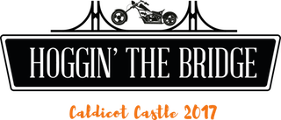

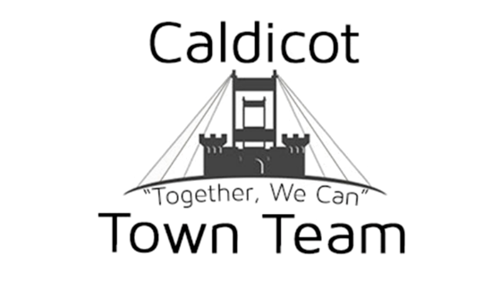
Please complete all fields in this booking form. Failure to do so will delay your booking. Please return this completed form to marketing@hogginthebridge.co.uk If you have any questions, please contact one of the team on 07716 557289,

Please note:
- All bookings must be fully paid before September 31st 2017 this can be made by BACS. Any unpaid bookings will not be guaranteed a pitch, and may be cancelled altogether.

- Should you wish to hire a gazebo from us, you can do so at a rate of £4 per day. Gazebos are very limited and hired on a first come, first serve basis, you will receive confirmation of hire once booking has been confirmed. (We offer two sizes, 3x3m or 3x6m)

- Once your booking has been confirmed, you will receive email confirmation along with a final copy of this booking form.

- Details of the event will be advertised on our website www.caldicottownteam.co.uk as well as www.hoggin-the-bridge.co.uk and social media sites, such as, but not limited to Facebook and Twitter.

- Failure to attend the event will result in loss of your entire pitch fee.

- Should the event be cancelled by Caldicot Town Team, all pitch fees will be returned within 7 working days from the original date of the event.

- Please read the terms and conditions that can be found at the back of this form. Your signature at the end of the form confirm you have read and agreed to these.

- An information sheet is sent out approx. 7 days before the event, please make sure you add your email address to the form, as all correspondence is recommended through email, to ensure a paper trail.

2017 Event Booking FORM
Event Name & Date:Hoggin The Bridge 2017

SECTION 1:Event Details
Contact Information | Name: Click here to enter text.  Position: Click here to enter text.  Telephone: Click here to enter text.  Mobile: Click here to enter text.  Email: Click here to enter text. l:
Company Name | Click here to enter text.
Company Address  (If Applicable) | Click here to enter text.
Company Postcode  (If Applicable) | Click here to enter text.
Stalls/Pitches Needed | Number:Click here to enter text.
Use of Stalls  Please state what the stalls will be used for/selling at the event. Please state the type and size of your stall | Stall Type: Click here to enter text.  Stall Size: Click here to enter text.
Gazebo Hire  You can, if you wish hire a gazebo from us at a cost of £4 per day.  (Note: Gazebos are very limited and hired on a first come, first serve basis, you will receive confirmation of hire once booking has been confirmed) | Click here to enter text.
Arrival Times  Please can you let us know an approximate arrival time, on the day of the event | Arrival Time: Click here to enter text.
Electricity  Please tick here if you need the use of electricity, You will need to provide your own generator for the event. | Yes  No
Pitch Sizes & Fees
Pitch fees can be paid via BACS, cash or cheque. You will receive additional information with your confirmation email.

Please note: These prices are for all NON-FOOD pitches, for food trader prices please contact us directly to discuss.
Account Name: Caldicot Town Team
Account Number: 03306119
Sort Code: 20-60-58
Please put EVENT DEPOSIT as reference.
Cheques are to be made payable to Caldicot Town Team.

Relevant Insurances
Please confirm you have the following insurances in place – We will need to see proof of these before the event, you can submit along with your application form.
(if required)

 | Pitch size no bigger than;
 | 3 x 3 meters £30
 | 3 x 6 meters £55
 | 3 x 9 meters £75
 | 6 x 6 meters £110
 | 6 x 9 meters £150
Other (POA)
Please state _______________
Public Liability:☐
Food Hygiene Certificate:☐
Employers Liability:☐
First Aider:☐
Qualified Electrician: ☐
CRB registered Staff:☐

Terms & Conditions
- Stall holders are allowed to enter the site from 6:30am to set up
- Stall set up has to be completed by 11:00 a.m. at the latest and vehicles parked in the designated areas.
- Stalls cannot set down, or leave the site until 4pm at the earliest.
- Stall holders are responsible for the safe keeping of all goods or items on their stalls. Caldicot Town Team / Hoggin The Bridge will not be held responsible in any way for the loss or damage to stall holders property throughout the duration of the event
- Insurance: stall holders are required to take out the necessary insurance against fire, theft and all other risks including third part claims. The stall holder must also indemnify Caldicot Town Team / Hoggin the Bridge against all claims, damages or expense whatsoever in any way arising out of their attendance or exhibits on the event site.
- Caldicot Town Team / Hoggin the Bridge reserves the right to refuse admission or change the site plan at their discretion. Hoggin’ the Bridge reserves the right to refuse an application for stall space.
- Stall cleaning: Stall holders are responsible for the cleanliness of their stalls and all rubbish must be removed to the bins situated on site. Adequate litter bins must be provided by stall holders on their stalls, should they anticipate producing a volume of litter throughout the day.
- By filing in your details on the booking form, you give permission for your company name to be used in any and all social media posts, including links from our websites.
- Please note most stalls are located on a grass pitch so please ensure you have sufficient floor coverings if required.
- Whilst we allow charities to have a pitch at the event free of charge, we do kindly request that any fundraising on the day is solely for Hoggin The Bridge, unless express written permission is obtained prior to the event.
Don’t forget to sign the form on the following page, failure to do so will result in a delay in your booking.
Please confirm that the information provided above is correct and then sign and print your name below.

Sign

X
Manager/Owner

Print

X
Manager/Owner

Dated
X
Manager/Owner

Please return this completed form to marketing@hogginthebridge.co.uk. Our postal address is: C/O Country Flowers, 38 Newport Road, Caldicot, NP26 4BQ

If you have any further questions, please contact Aaron Reeks on 07716 557289

