
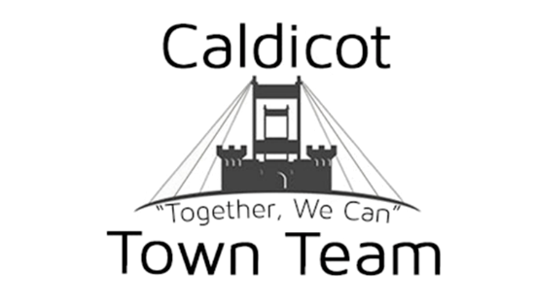
Family Fun Day Booking FORM
Please complete all fields in this booking form. Failure to do so may delay your booking. Please return this completed form to cttmarkets@outlook.com. If you have any questions, please contact one of the team on 07716 557289 or leave a message on our landline 01291 422644.

Please note:
- All bookings require a pitch fee of £25.00 (£50 for food traders) which can be made by cheque or BACS. Payment MUST be made before the date of the market, or your pitch may not be guaranteed.

- Should you wish to hire a gazebo from us, you can do so at a rate of £4 per day. Gazebos are very limited and hired on a first come, first serve basis, you will receive confirmation of hire once booking has been confirmed.

- Once your booking has been confirmed, you will receive email confirmation along with a final copy of this booking form

- Details of the event will be advertised on our website www.caldicottownteam.co.uk as well as on social media sites, such as, but not limited to Facebook and Twitter.

- Failure to attend the event will result in loss of your pitch fee.

- Should the event be cancelled by Caldicot Town Team, all pitch fees will be returned within 7 working days.

- Please read the terms and conditions that can be found on our website, should you need a hard copy, do let us know.

- An information sheet is sent out approx. 4 days before the event, please make sure you add your email address to the form.

Event Name & Date:Click here to enter text.

SECTION 1:Event Details
Contact Information | Name:  Position: Click here to enter text.  Telephone: Click here to enter text.  Mobile: Click here to enter text.  Email: Click here to enter text.
Company Name | Click here to enter text.
Company Address  (If Applicable) | Click here to enter text.
Company Postcode  (If Applicable) | Click here to enter text.
Stalls/Pitches Needed | Number:Click here to enter text.
Use of Stalls  Please state what the stalls will be used for/selling at the event. Please state the type and size of your stall | Stall Type: Click here to enter text.  Stall Size: Click here to enter text.
Gazebo Hire  You can, if you wish hire a gazebo from us at a cost of £4 per day.  (Note: Gazebos are very limited and hired on a first come, first serve basis,, you will receive confirmation of hire once booking has been confirmed) | Click here to enter text.
Arrival Times  Please can you let us know an approximate arrival time, on the day of the event | Arrival Time: Click here to enter text.
Electricity  Please tick here if you need the use of electricity, this is on a first come first basis as power points are limited | Yes  No
Pitch Fees  Pitch fees can be paid via BACS, cash or cheque. You will receive additional information with your confirmation email.  Account Name: Caldicot Town Team  Account Number: 03306119  Sort Code: 20-60-58  Please put EVENT DEPOSIT as reference.  Cheques are to be made payable to Caldicot Town Team.  Relevant Insurances  Please confirm if you have the following insurances in place  (if required) | £25  (No Gazebo)  BACS:☐  Cheque:☐ | £29  (Hire of Gazebo)  BACS:☐  Cheque:☐
 | £50  Food Trader  BACS:☐  Cheque:☐ | £29  (Hire of Gazebo)  BACS:☐  Cheque:☐
Public Liability:☐
Food Hygiene Certificate:☐
Employers Liability:☐
First Aider:☐
Qualified Electrician: ☐
CRB registered Staff:☐

Please confirm that the information provided above is correct and then sign and print your name below.

Sign

X
Manager/Owner

Print

X
Manager/Owner

Dated
X
Manager/Owner

Please return this completed form to cttmarkets@outlook.com.Our postal address is: C/O Country Flowers, 38 Newport Road, Caldicot, NP26 4BQ
If you have any further questions, please contact Aaron Reeks on 07716 557289

