
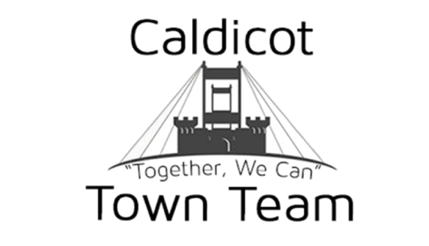
Car Boot Booking FORM

Date of Car Boot Sale:Click here to enter text.

SECTION 1: Your Details
Contact Information | Name:  Position: Click here to enter text.  Telephone: Click here to enter text.  Mobile: Click here to enter text.  Email: Click here to enter text.
Fees  The fee can be paid via BACS, cash or cheque. You will receive additional information with your confirmation email.  Account Name: Caldicot Town Team  Account Number: 03306119  Sort Code: 20-60-58  Please put Car Boot as reference.  Cheques are to be made payable to Caldicot Town Team. | £5  (Per Car)  BACS:☐  Cheque:☐  Cash:☐ | £8  (Vans)  BACS:☐  Cheque:☐  Cash:☐
 | All payments must be paid before the day of the event.

Please return this completed form to caldicottownteam@outlook.com. Our postal address is: C/O Country Flowers, 38 Newport Road, Caldicot, NP26 4BQ

If you have any further questions, please contact Aaron Reeks on 07716 557289

Terms & Conditions

- Sellers are not allowed on site until 9am on the day of the event
- Entrance must be gained from Newport road (petrol station) side of the town
- Organisers will be on site to guide you to your pitch.
- A one-way system is in operation, exit will be at the junction of Chepstow Road/Church Road
- All vehicles must have hazards lights on when driving through the town centre
- Maximum speed of 5mph AT ALL TIMES
- Emergency contact number 07716 557289
- Toilets are available in Jubilee Way car park.
- Caldicot Town Team hold Public Liability Insurance for the running of Car Boot Sales.

Prohibited & restricted items

This list is not exhaustive and can be reviewed at any time.

- All Flammable materials
- Weapons; i.e. Knives, Guns & Swords
- Fuel i.e. petrol/diesel
- Tobacco/Alcohol
- Live Animals
- Counterfeit goods

